**Evolutionary Robotics Final Project**

P. Alexander Burnham

11, April 2018

Does robot joint and limb morphology affect evolutionary response using a distance-based fitness function?

**Time Line 5) Develop a nested protocol to take evolved ANNs and use them to begin the next round of evolution**

This week I altered my plan. I decided to do away with the nested protocol. I believe to test my question, running many replicates with large population sizes for many generations is the most important goal. I have 8 treatments so I decided to start preparing for the actual experiment. In addition, I noticed a few glitches with my program. One of the legs in the six-legged robot tends to rise up out of the body as seen below. In addition, some runs will throw errors suggesting dimension mismatches between the genome matrix and functions that index through it.

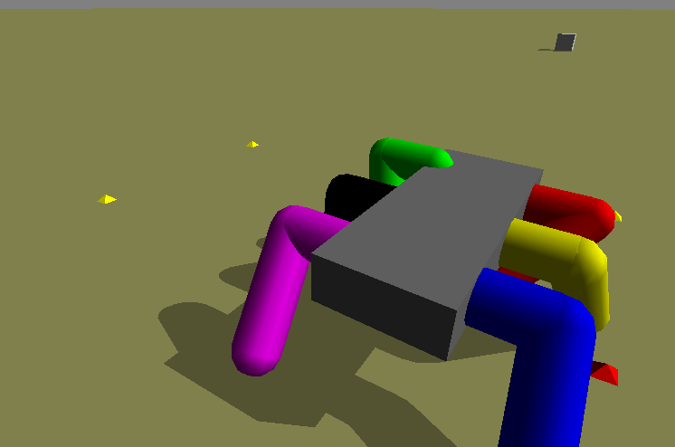This week, I embarked on tackling the bugs that I encountered. I also worked on pulling out fitness values after each run and exporting them from the program as a .csv file. This proved to be more complicated than I had thought but I have now implemented data saving. In addition, I ran two of my robots on both terrain types in order to test this data-saving capability. I have begun an R script (which is now in my EvoRobotics github repository) for data analysis. I used ggplot to create an example fitness curve for each of those runs (Figure 1). In future, those curves will be the means of multiple replicate runs.



Figure 2: Four fitness curves for two different robots (R3 = horizontal joint normals and R4 = vertical joint normals) as well as two terrain types, rough and smooth. Each line shows the distance-based fitness metric over the course of 50 generations. Each line represents the best individual from a population of 10 for one run.